3a-1 Domain, DNS and TLS Certificates with Let's Encrypt

Class Activity Overview
This lab introduces students to setting up a complete Internet-facing web presence. Students will configure a cloud VM, purchase and link a domain name, set DNS records, and secure their site with HTTPS using Let's Encrypt. The goal is to empower students to create real online services with full control.

Learning Objectives
- - Launch a cloud VM and configure firewall access (ports 22, 80, 443).
- - Install and run a basic Apache web server.
- - Purchase and manage a domain name via a registrar.
- - Link domain to VM public IP using DNS A record.
- - Verify domain resolution using ping and nslookup.
- - Obtain and install a TLS certificate via Let’s Encrypt.
- - Understand DNS propagation, redundancy, and failover behaviour.

Lab Setup and Tasks
- - Launch Ubuntu VM using Amazon EC2, Azure, or DigitalOcean.
- - Ensure inbound ports 22 (SSH), 80 (HTTP), and 443 (HTTPS) are open.
- - Install Apache: `sudo apt install apache2`.
- - Record public IP address of the VM. Access in browser to confirm Apache page.
- - Register a domain (Namecheap, GoDaddy, Cloudflare, Route 53, etc).
- - Create an A record pointing your domain to the public IP of your server.
- - Wait for DNS propagation and test with browser, ping, and nslookup.
- - Install Certbot: `sudo apt install certbot python3-certbot-apache`.
- - Run: `sudo certbot --apache` to generate and install the certificate.
- - Check site: HTTPS lock icon should appear in browser.

Experimentation and Advanced Tasks
- - Who issued the SSL certificate for murdoch.edu.au and csn.murdoch.edu.au?
- - Can you use a subdomain to point to another student’s server?
- - Create two A records with different IPs. Observe failover behaviour.
- - Shutdown server and observe DNS delay in failover. Discuss why.
- - Reflect on DNS load balancing, round-robin, and high-availability use cases.

Budget and Cost Monitoring
- - Visit EC2 Billing Dashboard to monitor charges.
- - Set a budget and create usage alerts under AWS Budgets.
- - Terminate unused instances to avoid unnecessary charges.
- - Avoid running expensive instance types (e.g. with GPUs) if not required.
- - Disable domain auto-renew if not continuing use post-semester.

Reflection Questions
- - What is the role of DNS in Internet presence?
- - Why does DNS propagation take time?
- - How does Let’s Encrypt validate domain ownership?
- - What are the risks if TLS is not configured on a public-facing site?
- - What could happen if you leave your cloud VM running for months?

🟢 Activity 1: Domain, DNS
📦 Deliverables:
# | Deliverable | Description
1 | Domain Name Registered | A registered domain from Namecheap, GoDaddy, Route 53, or similar: Duckdns.org/domain
2 | A Record Created | DNS A record pointing your domain to your VM's public IP
3 | Apache Installed | Apache2 running and accessible on port 80
4 | Public IP to Domain Mapping Verified | Test using nslookup, dig, and browser to confirm DNS is working
5 | Screenshot: Apache Welcome Page via Domain | Open http://yourdomain.com and capture the Apache welcome page
6 | Screenshot: DNS Test Output | Output of nslookup yourdomain.com or dig
7 | (Optional) Subdomain Experiment | A record pointing a subdomain (e.g., test.yourdomain.com) to another IP and screenshot of test result

🟢 Activity 2: Let’s Encrypt TLS Certificate Setup
You secure your domain with HTTPS by installing a free Let's Encrypt TLS certificate using Certbot.
📦 Deliverables:
# | Deliverable | Description
1 | Certbot Installed | Certbot and Apache plugin installed via Snap
2 | HTTPS Enabled on Domain | https://yourdomain.com should show a secure lock icon
3 | Valid TLS Certificate | Certificate issued by Let’s Encrypt (viewable in browser)
4 | Screenshot: HTTPS with Lock Icon | Browser screenshot showing lock and certificate issuer
5 | Screenshot: Certbot Success Message | Output of sudo certbot --apache command
6 | Screenshot: Renewal Dry-Run Output | Output of sudo certbot renew --dry-run showing success
7 | (Optional) Expired Certificate Simulation | Screenshot or explanation of what happens when the cert isn't renewed (if explored)
Hands-on experience with DNS, web hosting, and SSL certificates using entirely free services.

For students learning web hosting, a simple free setup is:
Part 1 – Register a Free Domain Name (DuckDNS)
Step 1: Create a DuckDNS Account
- Go to Duck DNS
- Sign in using:
  - Google
  - GitHub
  - Reddit
  - Twitter/X

Step 2: Create a Subdomain
- Enter a name, e.g.:
mywebapp
- Click Add Domain
- You will receive:
mywebapp.duckdns.org

Step 3: Configure Dynamic DNS
- Install DuckDNS client on your server/VM.
- Obtain your DuckDNS token.
- Configure periodic updates.
Example Linux command:
mkdir ~/duckdns
cd ~/duckdns
nano duck.sh
Paste:
echo url="https://www.duckdns.org/update?domains=mywebapp&token=YOURTOKEN&ip=" | curl -k -o ~/duckdns/duck.log -K -
Make executable:
chmod 700 duck.sh
Test:
./duck.sh
Verify:
nslookup mywebapp.duckdns.org

Part 2 – Install a Web Server
Ubuntu:
sudo apt update
sudo apt install nginx -y
Check:
systemctl status nginx
Browse to:
http://SERVER-IP
You should see the Nginx welcome page.

Part 3 – Point Domain to Server
Check current IP:
curl ifconfig.me
Verify:
ping mywebapp.duckdns.org
The IP should match your server's public IP.
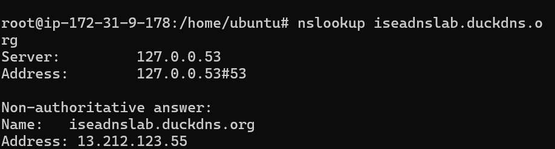
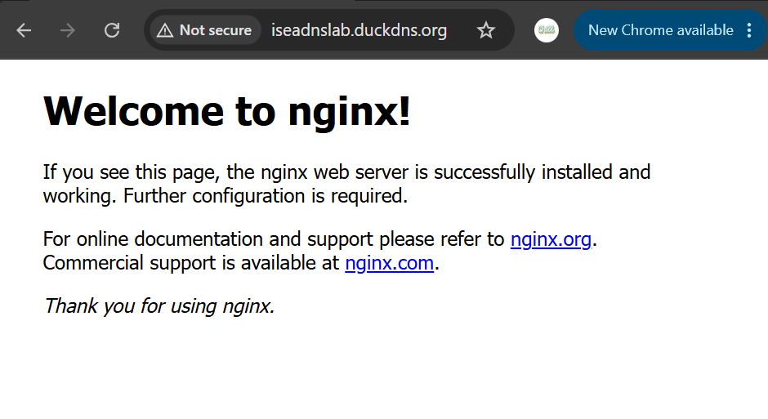

Part 4 – Open Firewall Ports
Allow:
Port | Purpose
80 | HTTP
443 | HTTPS
Ubuntu:
sudo ufw allow 80
sudo ufw allow 443
sudo ufw enable
Cloud VM:
- AWS Security Group
- Azure NSG
- Google Cloud Firewall
Must also allow TCP 80 and 443.
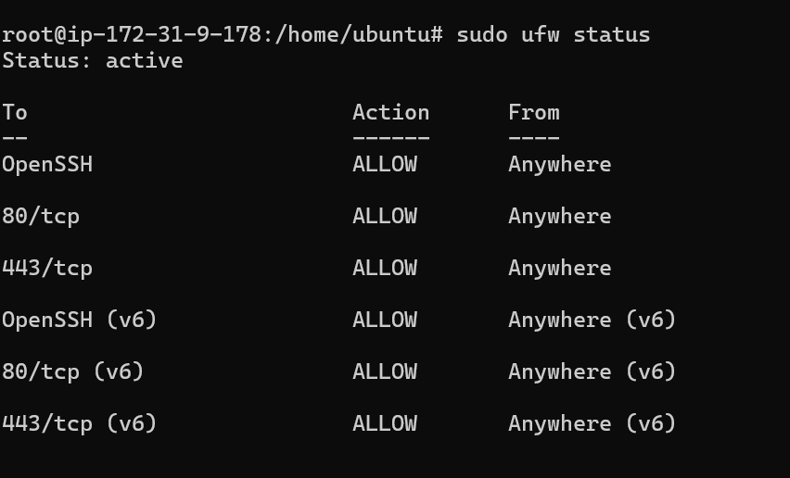

Part 5 – Obtain Free SSL Certificate (Let's Encrypt)
Install Certbot:
sudo apt update
sudo apt install certbot python3-certbot-nginx -y
Request certificate:
sudo certbot --nginx -d mywebapp.duckdns.org
Provide:
- Email address
- Accept Terms
Certbot will:
- Verify domain ownership
- Install certificate
- Configure HTTPS
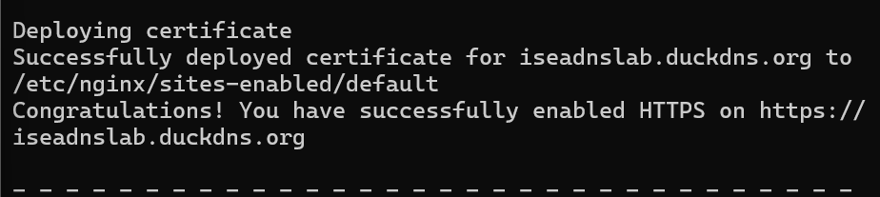

Part 6 – Test HTTPS
Open:
https://mywebapp.duckdns.org
You should see:
🔒 Secure Connection
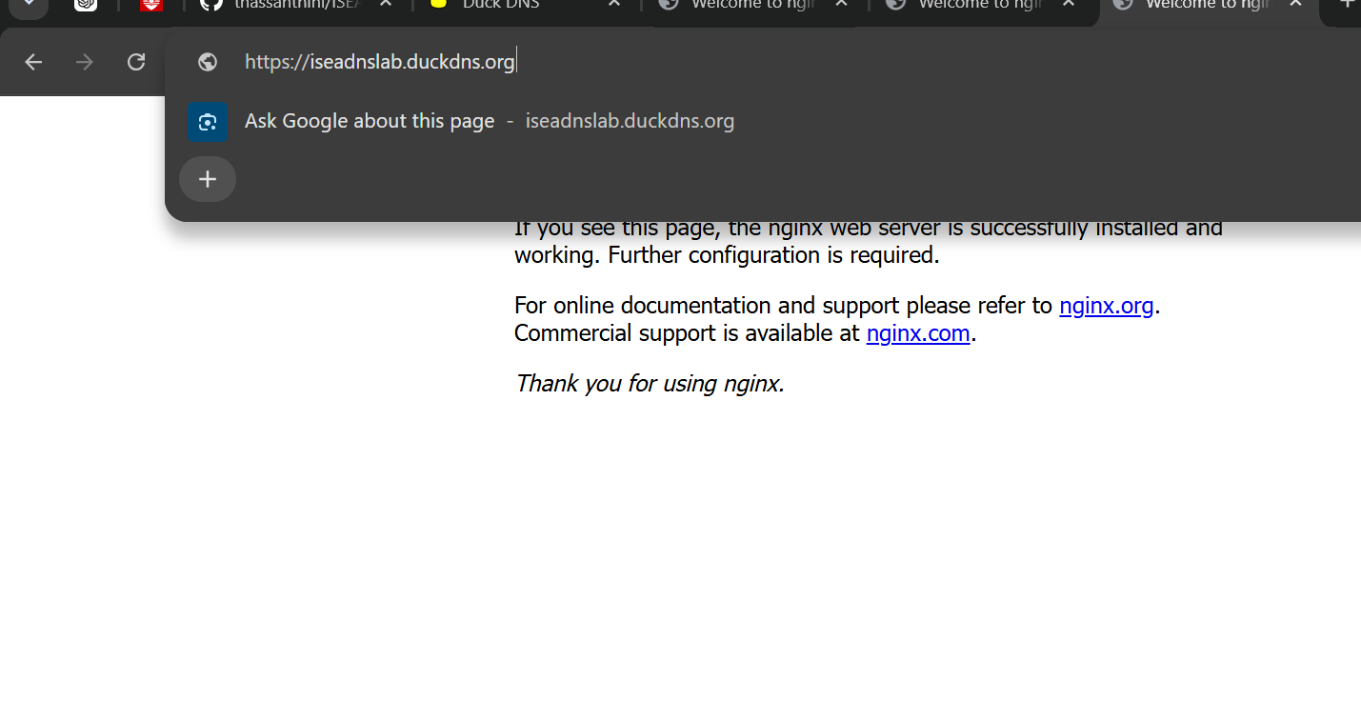

Part 7 – Verify Certificate
Check:
sudo certbot certificates
Example:
Certificate Name: mywebapp.duckdns.org
Expiry Date: 2026-09-10
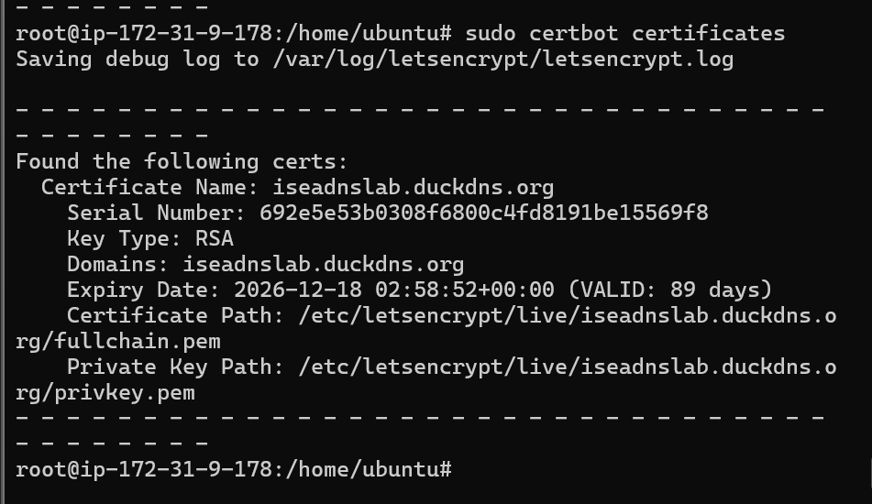

Part 8 – Auto-Renew SSL
Test renewal:
sudo certbot renew --dry-run
Check timer:
systemctl list-timers | grep certbot
Let's Encrypt certificates renew automatically every 90 days.
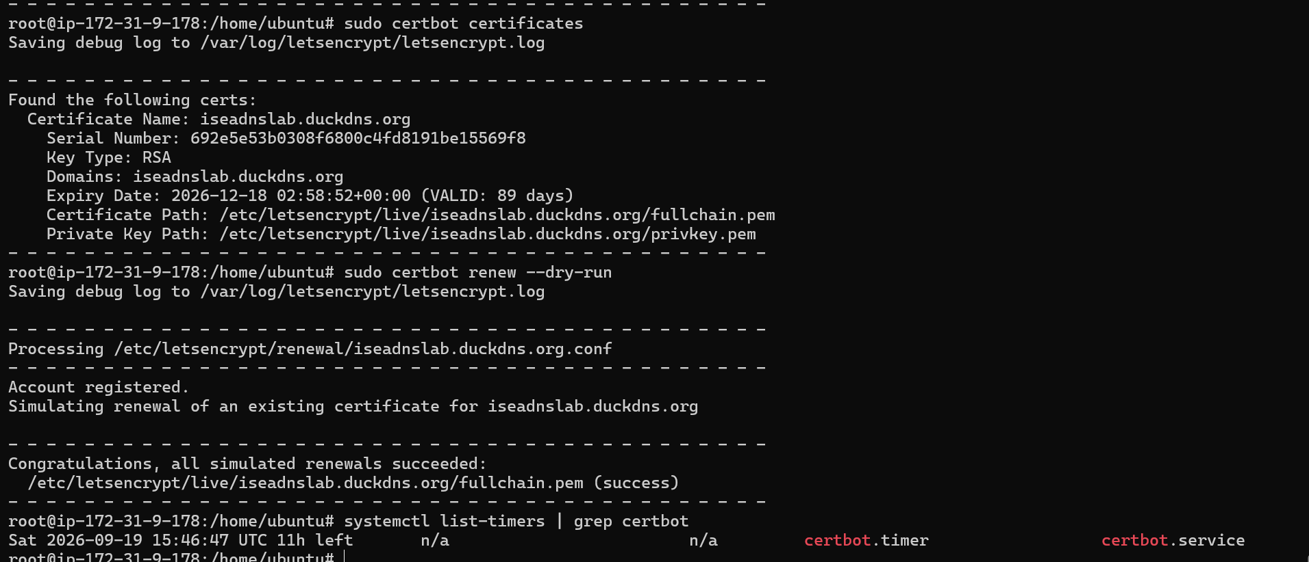

Architecture Diagram
Student Browser
|
| HTTPS (443)
v
mywebapp.duckdns.org
|
v
DuckDNS DNS Service
|
v
Public IP Address
|
v
Nginx Web Server
|
v
Student Website

Lab Deliverables
Students should submit:
- Screenshot of DuckDNS domain creation
- 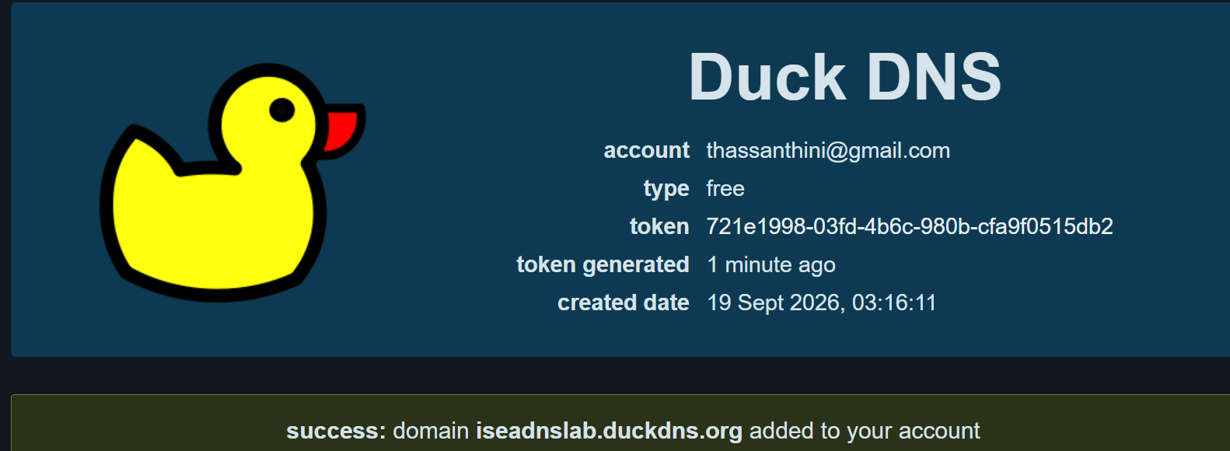
- Screenshot of ping mywebapp.duckdns.org
- Screenshot of Nginx running 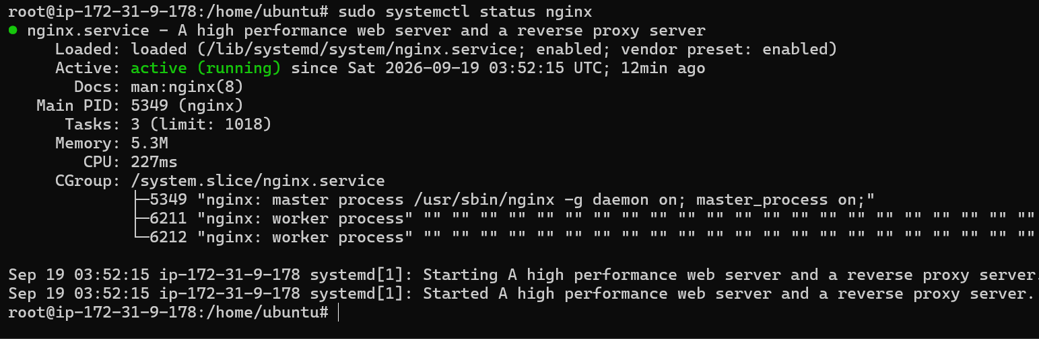

- Screenshot of HTTPS browser padlock
- 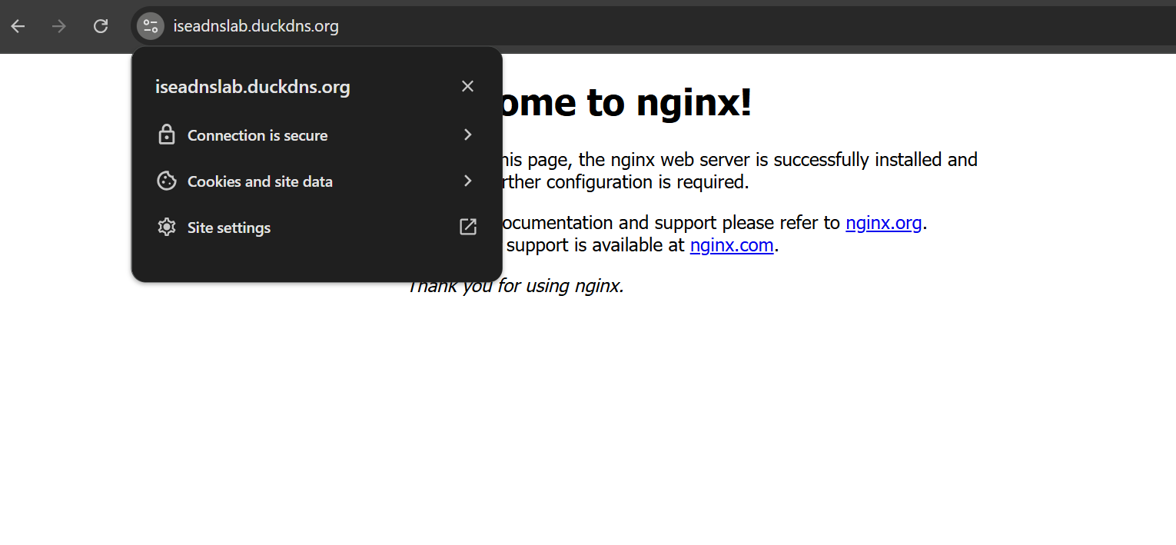
- Output of:
sudo certbot certificates
- Short explanation:
  - What is DNS?
  - What is a domain name?
  - What is SSL/TLS?
  - Why use HTTPS instead of HTTP?
  - What does Let's Encrypt provide?

What is DNS?
DNS, or Domain Name System, translates human-readable domain names such as iseadnslab.duckdns.org into IP addresses such as 13.212.123.55 so computers can locate servers on the Internet.

What is a domain name?
A domain name is a readable Internet address used to identify a website or service. Instead of remembering a numerical IP address, users can access a server using a name such as iseadnslab.duckdns.org.

What is SSL/TLS?
SSL/TLS is a technology used to secure communication between a client and a server. TLS is the modern protocol; the term SSL is still commonly used to refer to HTTPS certificates. TLS encrypts traffic and helps verify that the user is communicating with the intended server.

Why use HTTPS instead of HTTP?
HTTP sends data without encryption, while HTTPS uses TLS encryption. HTTPS helps prevent attackers from reading or modifying information transmitted between the user's browser and the web server. It also provides server authentication through a digital certificate.

